Submission Checklist
- Did you apply the correct Article Template for Word when preparing your manuscript? | √Yes/No*
- JPSE submission requires a Cover Letter addressed to editor. The cover letter must contain:  - An explanation that the manuscript has not been previously published, nor is it before another journal for consideration  - A novelty/finding and impact statement is required.  The cover letter must be prepared in .doc or .pdf and submitted in supplementary files in submission process. | √Yes/No*
- Review the Ethical Policy and obtain necessary clearances prior to submission. Have you obtained permission and given appropriate attribution to reuse figures, images, or other material from other sources? | √Yes/No*
- Have your co-authors approved the manuscript? | √Yes/No*
- Compile contact information for all co-authors. | √Yes/No*
- Identify the funding agency(s) for your research results. | √Yes/No*
*Please choose one
Malang, October 11, 2020

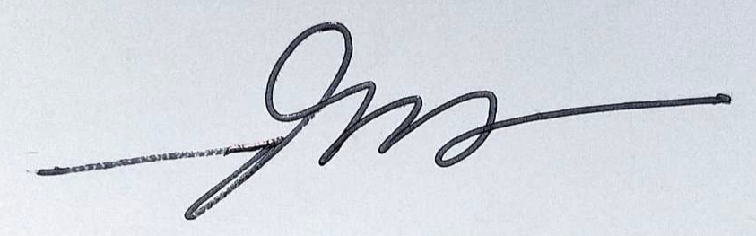

(Dini Mahirotul Aulia)
(Universitas Negeri Malang)

