GAMIFICATION IN ETHNIC EXCELLENCE-BASED CHARACTER AND CULTURE EDUCATION PROGRAMS

**Carolina M. Lasambouw1, Neneng Nuryati2, Ediana Sutjiredjeki3, Moh. Farid N.4, Sumeru5, Sri N. Yuliyawati6, Ade Hodijah7\***

1,2Department of Accounting, Politeknik Negeri Bandung

3,4,5Department of Electrical Engineering, Politeknik Negeri Bandung

6Department of Civil Engineering, Politeknik Negeri Bandung

7Department of Computer and Informatics Technology, Politeknik Negeri Bandung

Jl. Gegerkalong Hilir, Ciwaruga, Kec. Parongpong, Kabupaten Bandung Barat, Jawa Barat 40559 *e-mail: [ade.hodijah@polban.ac.id](mailto:ade.hodijah@polban.ac.id)

Paper received: 2022-10-12 revised: 2022-10-31 accepted: 2022-11-21

**Abstract***:* Bandung State Polytechnic (POLBAN) supports the Independent Learning Education, Merdeka Campus implementation by collaborating with the industry in game development to strengthen the values of the nation's cultural character and education. The game has five gamification components: badges, challenges, gifts, levels, and leader boards. This study conducts three activities which are Qualitative-Explorative, Qualitative-Descriptive, and Evaluation:

1. Qualitative-Explorative, POLBAN and industry listed the solution to support how the Pancasila character materials can be interesting for students by using the application. The user specification requirements is based on the 2021 research resulted in the 10 ethnic excellence based on the Pancasila character, which is Dayak, Madura, Jawa, Sunda, Baduy, Batak, Banjar, Minahasa, Betawi, Minang.
2. Qualitative-Descriptive, industry developed the application for the user as students and teachers. There are two applications. The first is the introduction of ethnicity, and the second is culture and character building based on ethnic excellence.
3. Evaluation, the application tested and socialized in the Pancasila and Civics Education (PPKN) class.

Hopefully, students will enjoy playing the game while learning the national materials. Thus, the gamification industry has students as markets.

**Keywords**: Character education, Gamification, Ethnic excellence

**Abstrak**: Politeknik Negeri Bandung mendukung pelaksanaan Pendidikan Belajar Mandiri, Kampus Merdeka bekerjasama dengan industri mengembangkan gamifikasi pada penguatan konsep pendidikan karakter dan nilai- nilai budaya bangsa. Game yang dikembangkan memiliki lima komponen gamifikasi yaitu: lencana, tantangan, hadiah, level, dan papan peringkat. Metode pengembangan game tersebut menggunakan tiga pendekatan yaitu Qualitative-Explorative, Qualitative-Descriptive, dan Evaluation:

1. Qualitative-Explorative, POLBAN dan industri menganalisis solusi agar pembelajaran materi karakter Pancasila menjadi menarik menggunakan aplikasi. Spesifikasi aplikasi berdasarkan hasil penelitian 2021 terkait daftar karakter Pancasila yang bersumber pada 10 karakter unggul, yaitu: Dayak, Madura, Jawa, Sunda, Baduy, Batak, Banjar, Minahasa, Betawi, Minang.
2. Qualitative-Descriptive, industri mengembangkan aplikasi untuk siswa dan guru sebagai pengguna aplikasi. Terdapat dua aplikasi yang dibangun. Pertama adalah pengenalan etnis dan budaya, dan kedua adalah pembangunan karakter berbasis keunggulan etnis.
3. Aplikasi di uji dan disosialisasikan pada jam pelajaran Pendidikan Pancasila dan Kewarganegaraan (PPKN).

Diharapkan gamifikasi dapat diintegrasikan ke dalam proses pembelajaran mata pelajaran wajib nasional. Dengan demikian, mahasiswa dapat menjadi pengguna dan pasar bagi industri gamifikasi.

**Kata kunci**: Pendidikan karakter, Gamifikasi, Keunggulan Etnis

1. **Introduction**

Students' good behavior is the main character of national education standards (Pemerintah et al., 2005). Moreover, character education ensures students have a Pancasila spirit (Karakter, 2017). Bandung State Polytechnic (POLBAN) studied the research on the character in education activities in 2021. There are two outputs of the 2021 research, which are handbooks (user manual guide) and web-based applications (product) where lecturers and students are the users of it (C. M. Lasambouw et al., n.d.). Therefore, strengthening character education is studied to be part o the POLBAN’s Merdeka Learning program with the purpose as follows:

1. To create mutualism between the industries and universities in various partnering activities.
2. To motivate other universities in having collaborated with the industries.
3. To enrich the education media alternatives which have more fun to study and it make students in learning the Pancasila character.
4. Direct students involved in application development have an impact on increasing creativity in finding society problem solutions.

Based on the background description above, this study aims to know how gamification encourages character education using the virtual learning method approach from Blended Learning (Yamin & Syahrir, 2020).

1. **Methods**

There are three stages in this research shown in Picture 1 as follows:

1. Identifying the industrial needs in developing gamification products through brainstorming about the character of each area (Dayak, Madura, Jawa, Sunda, Baduy, Batak, Banjar, Minahasa, Betawi, Minang).
2. Determining the looks and scenarios of each actor through Focus Group Discussions (FGD).
3. Testing the gamification product by becoming a user of the application and filling out the questions for product improvements.

Picture 1. Methods

Interview and FGD

Qualitative- Explorative

Prominent ethnic characters

Qualitative- Descriptive

Online gamificati on

Evaluation

1. **Results and Discussion**

According to the to the description of the method above, here are the description for each stage as follows:

1. Qualitative-Explorative

There are five significant values of human behavior related to strength the character education, namely: (1) religion; (2) nationalist; (3) independence; (4) working together; (5) integrity (Ana Ir Handayaningsih, 2013), (Kemdikbud, 2019). In order to promote character education, the learning process in question employs a blended learning methodology with a teaching technique through online gamification. The goal of the online gamification in this study is to provide participating teams time for debate while they determine the best solution, assess the user's honesty by placing them in the gamification activity's conditions, and then have them respond accordingly. Students will gain knowledge about a variety of elite figures from Indonesian ethnic groups. The goal of the game is to put together a group of people of different ethnic backgrounds to arrange community service projects in a region of Indonesia.

RPG Maker MV (RPG Maker MV Tutorial, n.d.). was used to create the program based on these goals (RPG Maker MV Tutorial, n.d.). It is due to the requirement for screen sharing on a computer. Additionally, the creation of an asynchronous smartphone application is required as a measure of user sincerity. These parameters will include basic functions like smartphone-based variable addition and subtraction. Picture 2 depicts the gamification's technology setup.

Picture 2. Technological scenario of the game

Main program (PC)

Asynchronous

Parameter (Smartphone)

Final assessment

User

Mentor

Screen- shared

Based on these ethnic advantages, the following are the ten major characteristics that each of Indonesia's ten ethnic groups possesses: (C. M. Lasambouw et al., n.d.), (C. Lasambouw et al., 2022) as indicated in table 1: (1) honest/frank; (2) hard worker; (3) likes to work together; (4) religious/religious; (5) brave; (6) loyal/loyal; (7) immigrants; (8) firm; (9) sincere; and (10) friendly.

Table 1. Identification of excellent characters

|  |  |  |  |  |  |  |  |  |  |  |  |  |  |  |  |  |
| --- | --- | --- | --- | --- | --- | --- | --- | --- | --- | --- | --- | --- | --- | --- | --- | --- |
| **Dayak** | | | **Madura** | **Jawa** | | | **Sunda** | **Baduy** | **Batak** | **Banjar** | | **Minahasa** | | | **Betawi** | **Minang** |
| atient | | | Religi- | Militant | | | Cheer | Abstain | Assert- | Loyal | | Religi- | | | Sociali- | Noma- |
|  | | | ous |  | | | ful | from | ive | friend | | ous | | | st | ds |
|  | | |  |  | | |  | harm- |  |  | |  | | |  |  |
|  | | |  |  | | |  | ing |  |  | |  | | |  |  |
|  | | |  |  | | |  | others |  |  | |  | | |  |  |
|  | | |  |  | | |  |  |  |  | |  | | |  |  |
| Preser- | | | Indep- | Consis- | | | Emb- | Obey | Migra- | Like to | | Discipl- | | | Cultural | Simple |
| ving | | | endent | ttent | | | race | the law | nts | trade | | ine | | | practiti |  |
| culture | | |  |  | | |  |  |  |  | |  | | | oner |  |
|  | | |  |  | | |  |  |  |  | |  | | |  |  |
| Honest | | | Express | Loyal | | | Gentl | Collabo | Resilli- | Religious | | Mutual | | | Sincere | Hard |
|  | | | ive |  | | | e | ration | ent |  | | cooper | | | -ly | worker |
|  | | |  |  | | |  |  |  |  | | ation | | |  |  |
|  | | |  |  | | |  |  |  |  | |  | | |  |  |
| Sincere | | | Uphold | Assert- | | | Resp- | Preser- | The | Empathy | | Honest | | | Easy to | Straight |
|  | | | -ing | ive | | | ect | ving | golden |  | |  | | | get | -forw- |
| **Dayak** | | | **Madura** | **Jawa** | | | **Sunda** | **Baduy** | **Batak** | **Banjar** | | **Minahasa** | | | **Betawi** | **Minang** |
|  | | | selfest- |  | | |  | the | voice |  | |  | | | along | ard |
|  | | | eem |  | | |  | natural |  |  | |  | | |  |  |
|  | | |  |  | | |  | herit- |  |  | |  | | |  |  |
|  | | |  |  | | |  | age |  |  | |  | | |  |  |
|  | | |  |  | | |  |  |  |  | |  | | |  |  |
| Tough- | | | Be | Willing | | | Frie- | Demo- | Honest | Gentle | | Fair | | | Polite | Egalita- |
| ness | | | brave | to | | | ndly | cratic |  |  | |  | | |  | rian |
|  | | | | sacrif- |  | | | | | | | |
| ice |
|  |  | | |  |  | |  |  | |  | |  |
| Consis- | Migra- | | | Obey | Hum- | | Indep- | Consis- | | Loyal | | Love to |
| tent | nt | | |  | ble | | endent | tent | |  | | sing |
|  |  | | |  |  | |  |  | |  | |  |
| Be | Confid- | | | Uphol- | Easy | | Honest | Never | | Forgiving | | Strong |
| persis- | ence | | | ding | to get | |  | give up | |  | | brother |
| tent |  | | | self- | along | |  |  | |  | | -hood |
|  |  | | | este- |  | |  |  | |  | |  |
|  |  | | | em |  | |  |  | |  | |  |
|  |  | | |  |  | |  |  | |  | |  |
| Resili- | Straight | | |  |  | | Sincere | Strong | |  | | To be |
| ent | forwa- | | |  |  | |  |  | |  | | respon- |
|  | rd | | |  |  | |  |  | |  | | sible |
|  |  | | |  |  | |  |  | |  | |  |
| Fair | Frankly | | |  |  | | Assert- | Tough- | |  | |  |
|  |  | | |  |  | | ive | ness | |  | |  |
|  |  | | |  |  | |  |  | |  | |  |
| Be |  | | |  |  | | Loyal | Mutual | |  | |  |
| brave |  | | |  |  | |  | cooper- | |  | |  |
|  |  | | |  |  | |  | ation | |  | |  |
|  |  | | |  |  | |  |  | |  | |  |
| Keep- |  | | |  |  | | Upload |  | |  | |  |
| ing |  | | |  |  | | -ing |  | |  | |  |
| promi- |  | | |  |  | | their |  | |  | |  |
| ses |  | | |  |  | | custo- |  | |  | |  |

ms

1. Qualitative-Descriptive

There are two users of the application, which are students and teachers. Furthermore, to make the process of learning more engaging (Rahimah Wahid, 2019) by increasing motivation (Marisa et al., 2020), the application has five use cases , namely:

* View Leader Boards
* Select the Action
* Choose Character Badges
* Do Challenges For Each Stress Level
* Get Points

The use case of each user as shown in Picture 3 .

Picture 3. Use case the game

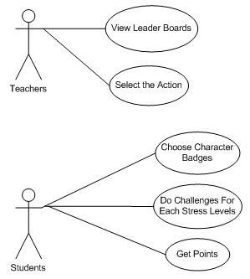

* Teachers run the application file (*.apk) on the computer and share it on the monitor screen for all students, as shown in Picture 4. After students agree with the response that should be done while playing the game, then teachers will “Select the Action” as the answer for each question.

Picture 4. Teachers application (computer)

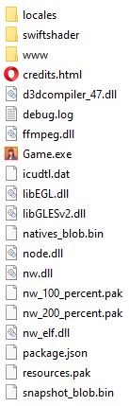

* Students manually prepare parameters by installing the application on a smartphone (android operating system) and “Choose Character Badges” as who they will play. It is seen in Picture 5. ·

Picture 5. Students application (smartphone)

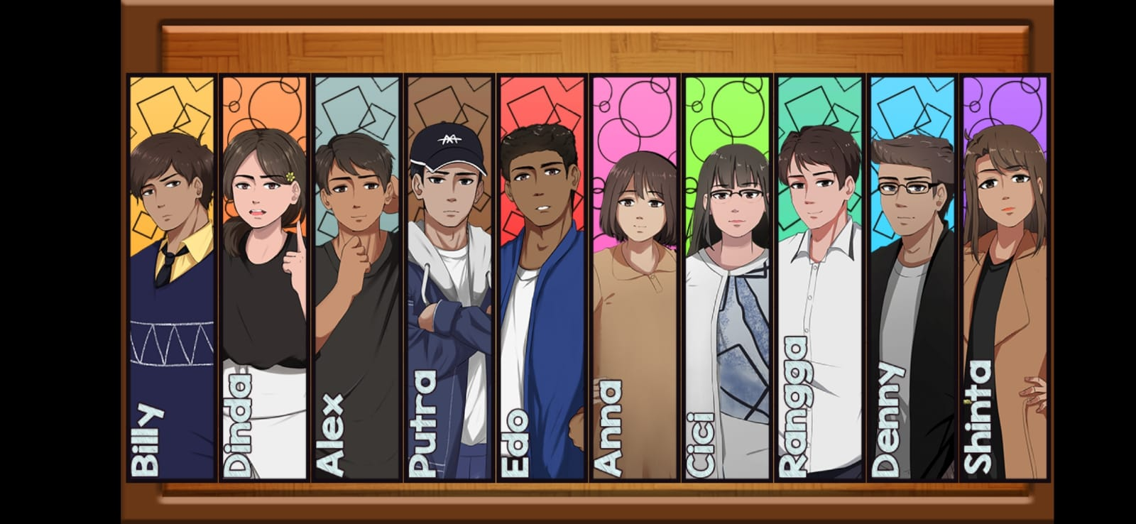

* At the first, students will watch the game scenario displayed as a story. After that, students have to response by choosing the answer for every questions shown on the screen. Students will “Get Points” either will increase or reduce the score after they “Do Challenges For Each Stress Levels”. However, the plot and result of the gamification activity are extremely likely to be impacted by this decision to act. Therefore, it needs to be thoroughly considered, decided, and debated (for the group). At specific times or occasions, the choice of the destination will also be discussed, or even made by each participant. There are situations when the location decision has an impact on the plot, as shown in Table 2 .

Table 2. Gamification locations

|  |  |
| --- | --- |
|  |  |
|  |  |
|  |  |

* Finally, teachers can compare the gamification results that are automatically recorded in the mentor's application (offered in the mentor's application with a separate menu “View Leader Boards”) to the results of the screenshots submitted by the user.

1. Evaluation

The following are five essential gamification attributes (badges, levels, leaderboard, virtual rewards, gifts, and challenges) of evaluating the results achieved by players (BOGDAN, 2019), (Uz Bilgin & Gul, 2020) as follows:

* Badges:

Badges serve as character identifiers for students while they are playing the games. Each character has a unique possibility from the other characters, and the computer will calculate each character's point automatically. The badges for the two applications (the first is the introduction of ethnicity, and the second is culture and character building based on ethnic excellence) are the same. Each character has two points measurements: stress meter and action points (AP) meter. The final total of the measurements for each character is shown on the leaderboards. The badges for each character is shown in Table 3.

* Challenges:

Students can compete to be the winner when they finish all the challenges, but if the answer is wrong, it will decrease the total point and determine the continuing challenges.

Picture 6. Gamification challenges

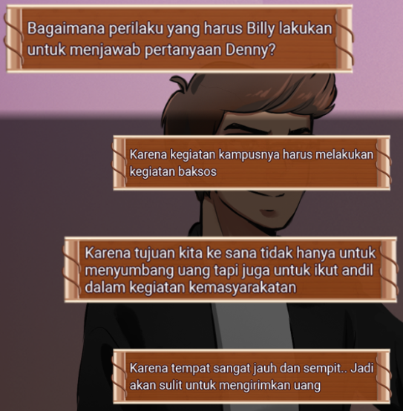

There will be a challenges addition when student reach certain points, which are new character that having by students. For example, Billy has a new character, “Tekun” or diligent, as shown in Picture 7.

Picture 7. Gamification challenges addition



Previously, Billy had four characters which are “Leadership”, “Tegas”, “Disiplin”, and “Berpikir Kritis”, as seen in Table 3.

Table 3. Gamification badges

|  |  |
| --- | --- |
| 1.png | 2.png |
| 3.png | 4.png |
| 5.png | 6.png |
| 7.png | 8.png |
| 9.png | 10.png |

* Gifts:

Students get money as gifts or rewards for reaching particular levels, which recruits its members, and the money will continue to increase as the group grows. However, money can work in groups and also apply to individuals. The mechanism of this money is called an Action Point. If a person reaches “0” (zero), this individual will quit the game.

Picture 8. Gamification gifts

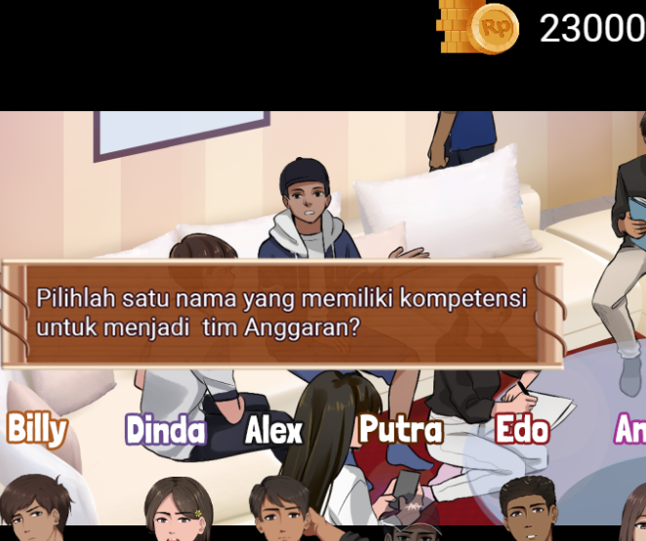

* Levels:

Besides the Action Point (AP), levels have stress stages of the game based on the level of the challenges. There is various combination of point formulation for the stress and AP related to the case complexity. For example, it is shown in Picture 9 that the stress point is added 2 points and AP is decreased to 1 point. Based on this point formulation, certain students who played the person in charge in conducting the action to resolve the case will reduce their points.

Picture 9. Gamification levels

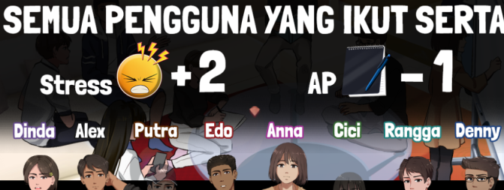

* Leader boards:

At first, students choose a character from the application installed on the smartphone. Each character has badges and status of points which measure all the actions done while playing the game. One of the gamification points measurements is shown in Picture 10.

Picture 10. Gamification points measurements

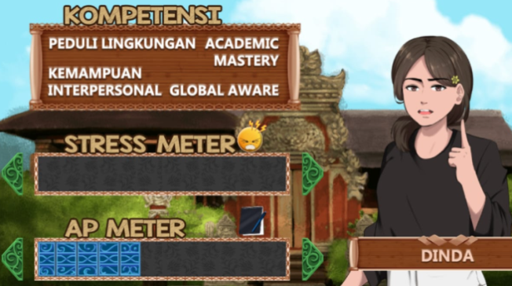

The final point of the measurements will be displayed on the leaderboards, which report the player's points after completing the game. The teacher can check all student results recorded automatically in the menu "REKAP RESULTS", as shown in Picture 11 and 12.

Picture 11. Gamification leader boards for stress points

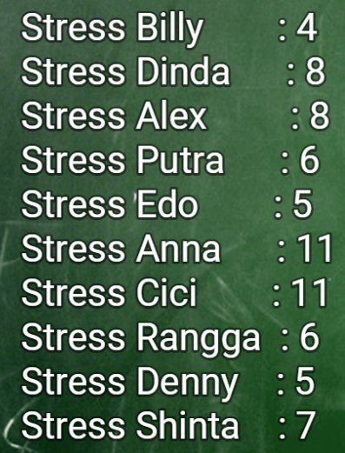

Picture 12. Gamification leader boards for action point points

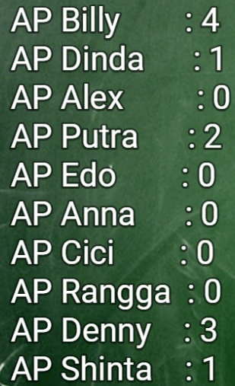

1. **Conclusion**

The study discovered that having "a real imagination" requires actual experience in applying national identity principles based on superior ethnic features. Using the gamification of character education programs, practical learning will provide a pleasant understanding of goodness from different tribes where each tribe has a notable character as the community's identity. The application of gamification creates a pleasant environment for learning based on the result where students tried to play the application until the end of the games.

**Acknowledgements**

This work funded by the Research and Community Service Centre of Politeknik Negeri Bandung, Indonesia, CV Kreatif Media Grafika Level-09 and Matching Fund Vocation (MFV) 2022, Diksi.

**References**

Ana Irhandayaningsih. (2013). Menyikapi Dekandensi Moral Di Kalangan Generasi MudIrhandayaningsiha. Humanika, 17(1), 125–138. https://media.neliti.com/media/publications/4995-ID-pendidikan-karakter-di-perguruan- tinggi-menyikapi-dekandensi-moral-di-kalangan-g.pdf

BOGDAN, I. (2019). Gamification Applied in Computer Science Education: A Preliminary Approach. Economy Informatics Journal, 19(1/2019), 52–58. https://doi.org/10.12948/ei2019.01.06

Karakter, P. (2017). Perpres 87 tahun 2017 tentang penguatan pendidikan karakter.

Kemdikbud. (2019). Konsep dan Pedoman Penguatan Pendidikan Karakter Tingkat Sekolah Dasar dan Sekolah Menengah Pertama. Kementerian Pendidikan Dan Kebudayaan Republik Indonesia, 8. https://cerdasberkarakter.kemdikbud.go.id/?wpdmpro=buku-konsep-dan- pedoman-ppk

Lasambouw, C. M., & Mathilda, F. (2020). A Most Significant Change Approach to Evaluating E- Learning Outcomes: An Initial Study in Pancasila (Civic) Course. 198(ISSAT), 662–667. https://doi.org/10.2991/aer.k.201221.106

Lasambouw, C. M., Nuryati, N., & Sutjiredjeki, E. (n.d.). Penguatan Pendidikan Karakter Berbasis Keunggulan Etnis melalui Integrasi Kurikulum Pendidikan Tinggi pada Era Revolusi Industri 4

. 0.

Lasambouw, C. M., Sutjiredjeki, E., Nuryati, N., Bandung, P. N., Ciwaruga, D., Elektro, T., Bandung,

P. N., Ciwaruga, D., Bandung, P. N., & Ciwaruga, D. (2020). KEUNGGULAN ETNIK DI INDONESIA UNTUK MENDUKUNG PENGUATAN PENDIDIKAN KARAKTER : SUATU STUDI AWAL ( The Advantages of Ethnics In Indonesia To Strengthen Character Education : An Initial Study ) PENDAHULUAN Penguatan Pendidikan Karakter ( PPK ) merupakan kebi. Seminar Nasional Terapan Riset Inovatif (SENTRINOV) Ke-6, 6(2), 480–487.

Lasambouw, C., Sutjiredjeki, E., & Nuryati, N. (2022). Excellence Ethnic Characters in Strengthening the Country National Values Identity: An Experience of Indonesia. Proceedings of the Annual Civic Education Conference (ACEC 2021), 636(Acec 2021), 1–7. https://doi.org/10.2991/assehr.k.220108.115

Marisa, F., Akhriza, T. M., Maukar, A. L., Wardhani, A. R., Iriananda, S. W., & Andarwati, M. (2020). Gamifikasi (Gamification) Konsep dan Penerapan. JOINTECS (Journal of Information Technology and Computer Science), 5(3), 219. https://doi.org/10.31328/jointecs.v5i3.1490

Pemerintah, P., Indonesia, R., Standar, T., Pendidikan, N., Rahmat, D., Yang, T., Esa, M., Republik, P., Nomor, U., Nasional, S. P., Pemerintah, P., Pendidikan, S. N., Negara, U. D., Indonesia, R., Nomor, U. R. I., Nasional, S. P., Tahun, L. N., Lembaran, T., Nomor, N., … Pasal, K. U. (2005). PP 19 tahun 2005 tentang standar nasional pendidikan. 1–54.

Rahimah Wahid. (2019). Kaedah gamifikasi sebagai alternatif pengajaran dan pembelajaran dalam kursus berkaitan alam sekitar. Journal of Education and Social Sciences, 12(2), 50–53.

RPG Maker MV tutorial. (n.d.). Retrieved October 4, 2022, from https://rpgmakermvtutorial.com/

Uz Bilgin, C., & Gul, A. (2020). Investigating the Effectiveness of Gamification on Group Cohesion, Attitude, and Academic Achievement in Collaborative Learning Environments. TechTrends, 64(1), 124–136. https://doi.org/10.1007/s11528-019-00442-x

Yamin, M., & Syahrir, S. (2020). Pembangunan Pendidikan Merdeka Belajar (Telaah Metode Pembelajaran). Jurnal Ilmiah Mandala Education, 6(1), 126–136. https://doi.org/10.36312/jime.v6i1.1121