Historical Study on the Development of the Weaving Motif of Bima, West Nusa Tenggara, Indonesia
Nursyahri Ramadhan¹, Tri Karyono², Zakarias Suteja³
Art Education, Graduate School, Universitas Pendidikan Indonesia, Jl. Dr. Setiabudi No.229, Isola, Kec. Sukasari, Bandung City, West Java 40154
syahrilramadhan@upi.edu¹

Abstrak
Budaya pemintalan kain sudah lama dikenal oleh bangsa Indonesia melalui akulturasi budaya pada masa ekspansi kekuasaan hingga masa perdagangan Nusantara, sehingga penyebarannya tidak hanya mencakup etnis besar seperti Jawa dan Melayu tetapi juga sampai pada pelosok etnis kecil yaitu Suku Bima, Nusa Tenggara Barat, Indonesia. Polemik yang muncul adalah kemiripan pada setiap motif yang menjadi ciri khas entitas suku dan mengandung nilai filosofis suatu etnis. Tujuan dari penelitian ini adalah untuk menelusuri sejarah awal masyarakat Bima mengenal tenunan dan motif-motif yang diterapkannya hingga terbentuk 8 motif yang ditetapkan dalam Hukum Adat Tanah Bima (HATB) sehingga menjadi Ciri khas etnis Bima. Metode yang digunakan pada penelitian ini adalah menggunakan pendekatan kualitatif dengan triangulasi data (observasi, wawancara, dan studi dokumen). Hasil penelitian ini menunjukkan bahwa kegiatan pemintalan benang telah dikenal oleh masyarakat Bima sebelum pengembaraan tokoh Sang Bima ke negeri matahari terbit (Pulau Satonda, wilayah vulkanik di pulau Sumbawa) yang menjadi cikal bakal orang Bima dan untuk membuat pakaian, menerapkan seperti cara orang-orang Jawa dalam hal menenun. Motif awal yang dikenal oleh orang Bima hanya berbentuk garis-garis dan segi empat, namun akulturasi budaya Jawa pada masa kejayaan Majapahit ikut mempengaruhi perkembangan motif-motif di kerajaan Bima pada abad ke 11-13, selanjutnya, terjadi akulturasi budaya Bugis dan Melayu setelah kerajaan Bima berubah menjadi kesultanan sehingga penerapan motif-motif dalam lingkungan masyarakat Bima mengacu pada Hukum Adat Tanah Bima yang sesuai dengan Syariat Islam.
Kata kunci: Sejarah, Motif-Motif, Tenun, Bima
A Historical Study on The Growth and Development Weaving Motifs in Bima, West Nusa Tenggara, Indonesia
The culture of spinning cloth has long been known by the Indonesian people through cultural acculturation during the expansion of power to the period of Nusantara trade, so that its spread does not only include large ethnic groups such as Javanese and Malays, but also reaches remote ethnic groups, namely the Mbojo tribe (Bimanese), West Nusa Tenggara, Indonesia. The polemic that arises is the resemblance to each motif that is characteristic of tribal entities and contains philosophical values ​​of an ethnicity. The purpose of this research is to trace the early history of the Bimanese to know the weaving and the motifs that it applies to form the 8 motifs defined in the Bima Land Customary Law so that they become the characteristics of the Bima ethnic. The study method used a qualitative approach with data triangulation (observations, interviews, and document studies). The research result shows that the activity of spinning yarn was known by the Bimanese before the odyssey of the character of Sang Bima to the land of the rising sun (Satonda Island, a volcanic area on the Sumbawa Island) which became the forerunner of the Bimanese and to make clothes, using the Javanese way of doing things. The initial motifs known by the Bimanese were only in the form of stripes and rectangles, but the acculturation of Javanese culture during the heyday of Majapahit also influenced the development of motifs in the Bima kingdom in the 11-13th centuries, subsequently,
Keywords: History, Motifs, Weaving, Bimanese

INTRODUCTION
Every region in Indonesia has local wisdom which is the result of local people's thinking that is of good value, full of wisdom, and contains wisdom values ​​that are embedded and followed in people's lives (Prasetyo & Kumalasari, 2021). In addition to the value of local wisdom contained in people's behavior, this value is also found in art objects ranging from Sumatra with traditional aesan gede clothing (Shanie & Sumaryanto, 2017), Javanese batik (N & Dewi, 2021), and Papuan noken. The central part of Indonesia is the island of Sumbawa, West Nusa Tenggara with two main tribes that inhabit it; the Samawa tribe for the Sumbawa people, and the Mbojo (Bima) tribe for the eastern part of the island of Sumbawa which includes the Bima people themselves and the Dompu people. One of the traditions that has long been known to mankind is the tradition of spinning yarn, weaving cloth, and sewing clothes. The weaving tradition has been known almost all over the world, from African civilization stretching to the American continent and to the Asian region, until arriving in the archipelago. Although the track record of who or which group was the initial inventor of the weaving technique, it is certain that this tradition has developed to the smallest remote areas..
The motifs found in woven fabrics are very diverse, the same as the motifs and colors of batik art which represent its pluralistic nature in accordance with the identity and character of each region. The unification of imagination in cultural and religious rituals makes batik have a symbolic meaning and even a plurality of batik motifs contains aesthetic-magical values ​​that are philosophical (Takdir & Hosnan, 2021). In the woven fabrics of indigenous peoples or certain areas, there are still many who do not understand the various types, colors and forms of motifs that become their identities, so it is necessary to do the same thing, especially in in-depth research to get history that can explain past civilizations scientifically starting from the beginning. which can be extracted in the community to woven fabrics as a commodity for the global economy. So that it is not only a cultural heritage, but at the same time it can improve the economic welfare of craftsmen. With the increasing number of studies on regional woven fabrics, it is hoped that they will complement each other and find common threads from past relationships so that they have a good impact on the historical motifs that influence each other in each region.
In songket woven cloth, the decoration is the embodiment of human and natural beauty. The decorative variety created on woven fabrics is based on human knowledge about the environment so that it can stimulate human thinking to create various forms of motifs in it. Natural objects such as plants, animals, humans, natural elements, to religious values ​​and beliefs are presented in a harmonious embodiment of beauty and then translated into forms of decorative motifs (Sila, 2013). The motifs contained in each woven fabric have various meanings; Malay society considers that this racial supremacy can be seen from the songket cloth and its motifs along with animist beliefs and Hindu-Buddhist and Islamic religious beliefs. The understanding of growth and development, unity and human spirituality related to animism is expressed in songket motifs (Bahauddin & Aldrin, 2003). Human relations that intersect with one another affect the development of culture and art in each region, cultural acculturation, starting from the expansion of the territory and local trade routes carried out by the Malays, Javanese and Bugis people then came to nations outside the archipelago. such as China and Arabia, which then at the beginning of the 16th century European nations began to touch the eastern areas in search of gold (spices) including Bima (Parimartha, 2016). Bima was an important area as one of the trade centers in the small Sunda region, and woven fabrics were an export item at that time (Van Braam Moris, 2014, p. 38) but now Bima weaving is difficult to restore its reputation as a result of many being abandoned. by the community and craftsmen who have now turned to jobs that are considered more economically promising, as well as a faded understanding of historical values ​​and philosophy of life.
The research on 'Traditional Weaving Fabrics of Nusa Tenggara' written by Kartiwa (1973) in the context of the Rehabilitation and Expansion Project of the Central Museum of Jakarta, was carried out as an effort to rehabilitate activities in the field of research and publication of the Central Museum. In this paper, it only describes the process, technique, and decoration of Nusa Tenggara weaving in general. Therefore, more detailed research is needed to obtain scientific literature material so that historical research on Bima weaving motifs is important. As for other studies (Mardyah, 2014; Mubin, 2018; Rosmini, 2018; Wijaya et al., 2014) which discuss the Bima weaving motif, all of them are limited to the philosophical meaning of the symbols contained in the Bima weaving motif. In this study, the explanation related to its development no longer refers to the development of the distinctive characteristics of the Bima weaving motif, but is only limited to the explanation of how to make and document the results of weaving so that in this research it is more to examine comprehensively the history of the growth and development of the Bima weaving motif from pre-Islamic times to the pre-Islamic period. the Bima sultanate was established.
This research is considered important to maintain the preservation of regional culture so that there is a need for a thorough study in maintaining local wisdom in Indonesian culture, lest traditional art be abandoned by supporters as a result of the massive influence of modern art. area (Tabrani, 2012, p. 100) coupled with the phenomenon of the lack of knowledge of the craftsmen to the types of motifs and philosophical values contained in traditional motifs which causes the depletion of local cultural preservation (Usop et al., 2021) to reduce these influences, understanding of local history needs to be written scientifically so it is hoped that there will be more sources of literature that can be referred to and used as reading material for the younger generation in understanding traditional arts.
The most important aim of this historical research is to make us aware of possibilities that are not normally considered because historians study the past not in order to repeat it, but in order to be free from it (Harari, 2020, p. 68). In this case, historical writing is very important to introduce the creativity of people who we consider primitive but their intelligence by creating works of art that can survive until now, so that what needs to be emphasized in writing history is not only telling a series of events that occurred in the past but more important is to study the creativity of the previous people to create local wisdom so that it will give birth to a generation that remains proud of local arts and culture then improvise and modify traditional art works into more modern forms so that they can be enjoyed throughout the ages.
METHOD
The method used in this research is a qualitative approach with data collection techniques, namely observation, interviews, and documentation studies. Sources of information, first made observations at the Asi Bima Museum. Furthermore, in Rabadompu, Bima City, which is the center of the famous weaving craft, as well as in Kale'o and Simpasai villages, Lambu sub-district, which are people who use Non-Machine Weaving Equipment (ATBM) the most Bima cloth in Bima Regency and almost every house has weavers so that it represents information to trace the history of the development of the Bima weaving motif. Interviews were conducted with the historian Bima (the writer) who also serves as the head of the Asi Bima museum, Mr. Ruslan Muhammad or better known (Alan Malangi), the ATBM craftsman Mrs. Nurseha (Kale'o) and Haninah (Simpasai) who are figures considered by the local community as experts and derivative craftsmen in each of these areas. In the document study, literature studies were carried out on scientific writings such as: journals, proceeding articles, books such as Bo' Sangaji kai and origin stories of all the Jin nations which are Bima's historical manuscripts and other supporting books, theses, theses, and dissertations, as well as documents. - related documents. So that the linkage of verbal sources with literature can complement each other.
DISCUSSION
History of Weaving Bima
In the transcription of the Schoemann V3 script, 'The Story of the Origin of the Jinn and all the Gods', tells the story of the character of Sang Bima after conquering all the kingdoms on the island of Java. He and his three younger brothers Sang Arjuna (Arjuna), Sang Kula (Nakula), and the God (Sahadeva) wandered in their boats to go to the land of the rising sun. On that voyage, they stopped at Satonda island, a volcanic island off the coast of Pekat (Tambora, Sumbawa Island) and then married a local woman named Putri Tasi Naga and had 2 children who became the forerunner of the Bima kingdom (Sjamsuddin, 2013, p. 5–7). The two children were named Indra Komala and Indra Zamrud. Back to the story of their birth, Putri Tasi Naga's mother, after giving birth to them, put her in a bamboo basket and covered it with pearls and then carried it into the sea and drifted to the land of Dompu. The two children were found by an Ncuhi (tribal leader) named Pata Kula, after the two sons of Sang Bima grew up, they were asked to become kings by the Ncuhi and the people. Indra Komala as the king of Dompu and Indra Zamrud was given territory in Bima. On his departure for Bima, Indra Zamrud was accompanied by Ncuhi Parewa wearing a red woven cloth with gold inlay and wearing a white, golden turban decorated with air bird feathers and holding a golden staff (Chambert-Loir, 2004, pp. 103–105). The transcript of the text above shows that the indigenous people of Bima have long known the weaving tradition because before the king of Bima founded the Bima kingdom, the indigenous Bima people had already settled in the area in small communities scattered around the mountains of the Bima bay called the Donggo/Dou Donggo people. (Hitchcock, 1987). In that incident the Ncuhi were already wearing woven cloth. Another view that is still relevant is that it is estimated that the Bima people began to recognize the tradition of making clothes to protect their bodies from environmental and weather conditions in Bima which is very hot and hot during the day but very cold at night (Van Braam Moris, 2014 , p.27). This history is believed by the people of Bima to be the beginning of the Bima people knowing weaving, namely since the Naka era (the oldest era in Bima's history).
Weaving Bima has begun to be known by outsiders in the trading activities of the Archipelago in 1512 AD, where traders who wanted to go to Banda and Maluku would stop at Bima Port and buy cloth made from local residents to be resold to Banda and Maluku (Pires, 2018, 2018). p.247). The trade route that connects from Malacca to Maluku is the main attraction in the Bima port so that this route is very crowded. The geographical location of Bima which is flanked by the Flores Sea and to the south by the Indian Ocean makes this area so important in the map of the archipelago's shipping lanes. In all seasons, especially in the west monsoon season, Bima bay is the safest place for ships and boats to dock. Traders who travel from the Malacca Strait to Banda or from Banda to Malacca in the west monsoon season, heavy storms often occur, making ships and boats sailing in the Flores sea into the bay for weeks until the storm subsides. The busiest activity at Bima port is during the north monsoon where according to Kenneth R. Hall that in that season the shipping lanes of China, Java, Nusa Tenggara and Maluku take advantage of the north and southeast monsoons, because in this voyage ships and boats generally need a port of call. to fill supplies or take shelter from strong winds and then also used for trading (Taufiqurrahman, 2012, p. 15–18). The ideal port of Bima brought Europeans to know this area, so that trading commodities at Bima port increased rapidly, especially Bima woven cloth which at that time was the prima donna and was greatly admired by the people of Banda and Maluku because of the quality of the cloth in Bima and Maluku. Sumbawa is very good (Pires, 2018, p. 268).
According to Noorduyn, in 1618-1619 the first entry of Islam in Bima was brought by the Gowa kingdom, but after fifty years Bima managed the kingdom, they had to submit to the power of the Company. At that time the people and kingdom of Bima underwent important changes. The boats that arrived in Batavia and in Ambon were recorded by the Dutch. The records from the boat carrying goods from Bima included: rice, sapan wood, wax material, sandalwood, tamarind, sulfur, cinnamon, Javanese sugar, and slaves (see: Daghregister 1624-1664). From these records, Bima was already in contact with Ambon, Banjar, Makassar, Banten, Palembang, and even China. Another note mentions that the merchandise carried by the ships included: woven cloth, horses, buffalo, onions, green beans, and ganitri seeds (Chambert-Loir & Maryam, 2012, p. xvi). From the results of the data collection, Bima woven cloth has always been an interesting item to be carried by outsiders, even Van Braam Moris recorded his experience while in Bima, namely that traders who want to sail from Maluku to Malacca or vice versa always stop to trade at the Bima port and surrounding areas, because the commodities in Bima besides cloth are horses, honey, sapan wood and candles. However, after the seventeenth century, the bustling trading activity that took place at the Bima port led to the proliferation of goods from abroad of better quality, such as finer fabrics from China. The yarn spinning activity in Bima still uses coarse yarn so that in general the ordinary people dress very simply, with a rough-looking cloth texture, red and white or blue and white with stripes or plaid which they make clothes using materials from Europe or those that come from Indonesia. Java, Makassar, Selayar, or Singapore (Van Braam Moris, 2014, p. 59).
The initial motif applied to the woven cloth of the Bima people is still the majority of clothing in Bima, it can be found in one of the weaving villages in Bima, namely Simpasai village, Bima. Based on information from the weavers. The people of Bima have known for generations the tradition of spinning yarn. Haninah (73) said that weaving has existed since the Naka era, because in the past people were not familiar with clothes like today, so to protect themselves from the weather and animal bites they did spinning activities from natural materials such as roots and bark. After some time the development and change of materials that are easier to find, especially cotton trees that are very abundant in the plains of Bima, the craftsmen/weavers use cotton as a material to make yarn. The cotton is made into coarse threads, then used as material for weaving. Initially the fabrics were made very rough unlike today. The development of the Bima woven motif in Simpasai village still maintains the types of geometric motifs, straight lines and forming boxes (nggusu upa motifs). This is done because the manufacture does not require a long time when compared to the manufacture of woven floral motifs. In addition, geometric motifs are also more sought after by Bima woven lovers so that in order to maintain their economic resilience they adapt to their needs while preserving ancestral heritage. The interesting thing is that the tradition of inheritance of weavers in Simpasai village still holds the old tradition, namely where women are implanted with a kind of suggestion that if women cannot weave, they are considered as immature women (not ready to marry). The concept was instilled by parents who have worked as weavers for generations so that they can preserve the weaving culture in Simpasai village. In fact, in general, children in Simpasai village are able to make a piece of cloth the size of one sarong at the age of 12 (Interview, May 2021).
In the mid-19th century AD, as written by Van Braam Moris (2014, pp. 29–35), the handicraft industry in Bima was very small and limited to the spinning of yarn for generations in traditional ways. They don't even use fine cotton, they weave using cotton from their own gardens or from the forest, because the mountains in Bima are mostly planted with cotton (one of the trade commodities) so that the Bima people only produce woven sarongs and scarves that are made of cotton. Rough. Regarding the handicraft business (weaving) for residents in Bima, it only appears as a distraction between the planting and harvesting seasons, and weaving work becomes important for those who live in remote villages (Zollinger in Parimartha, 2016, p. 57) .
The history of weaving in the archipelago is indeed very interesting to continue to be researched through a historical approach that is studied scientifically. The motifs made reflect the values ​​of regional philosophy (Siregar, 2016), although the weaving method is the same, the shape of the resulting motifs is different from one another. Historians believe that weaving has been known since the time of the Srivijaya Kingdom (7-14 AD). However, until now there has not been found archaeological historical evidence that justifies this opinion. The various opinions above have not yet found strong archaeological evidence in corroborating the early history of spinning yarn entering the archipelago, more specifically in Bima, which can be scientifically justified.
The Motifs in Weaving Bima
As with the history of the early decoration of human civilization in general, the people of Bima initially only recognized straight-line weaving motifs produced from natural colors. Chambert-loir writes in 'The Story of the Origin of the Jinn and All the Gods', when escorting Sang Bima's son named Indra Zamrud to the Bima region, the original Bima accompanying Ncuhi Parewa wore the original woven clothes of the Bima people with red clothes. gold (Chambert-Loir, 2004, p. 105). The resulting motif is still very simple, only striped and made roughly using leather and wood roots, as well as using natural dyes found in the Bima Region. Noorduyn noted that Bima was heavily planted with sepang or sapan wood trees, and became an export commodity during the trade period. Sapan wood is important because it is an attraction for Europeans. In the 16th century sapan wood products from the island of Sumbawa had emerged as a very important commodity, at this time sapan wood was sent to Malacca, then there it was passed on to China. As a result of the fall of Makassar (1667) Trade in sapan wood on the island of Sumbawa was monopolized by the Dutch Company, thus giving the Dutch special rights to buy sapan wood from these islands. With the existence of a company monopoly, this sapan timber trade only provides benefits for the kings while not having much positive impact on the trading crowd in the Sumbawa archipelago. Although not widely reported – around the 19th century – it appears that the sapan timber trade was still monopolized by the Dutch. This wood trade was only released by the Dutch after the emergence of synthetic materials for dyes in the second half of the 19th century so that sapan wood materials were no longer sold in Europe (Parimartha, 2016, p. 147). It can be assumed that the motifs produced in this early period were only limited to straight lines with natural coloring. Although archaeologically, the remains have not been clearly found in Bima.
The development of decoration in Bima began to vary when the Majapahit kingdom expanded to the East. This incident occurred around the 14th century where Riana (2009, p. 100) wrote in the Wirama Pthiwitala which are stanzas of the Majapahit kingdom's poetry that mentions the areas of the kingdoms in the East:
In the east of the land of Java is also mentioned,
Bali is the most important Be predecessor and Goa Gajah,
The most important deserts are Breadfruit, Taliwang, all Dompo,
Sang Hyang Api Bhima, Seran, Kadali Forest gathered

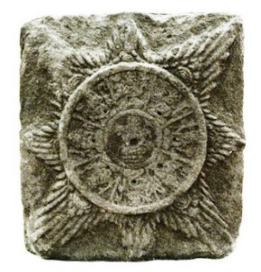
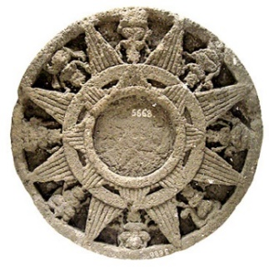
Apart from mentioning the names of the royal areas on Sumbawa Island, the Majapahit kingdom really wanted to control the Bima kingdom and its surroundings. The territory of the kingdoms on the island of Sumbawa became important with its trade routes that attracted Nusantara traders. So, in the amokti palapa oath sworn by Mahapatih Gajah Mada, he said that the kingdoms in the archipelago, one of which was in Bima (Dompo) would be conquered to unite the archipelago so that he could rest in peace (Suartaya, 2011). The history of acculturation of Javanese culture (Majapahit) with the Bima kingdom is explained by Susetyo (2014), a National Archaeological Researcher, found that the motifs that adorn the Sultan of Bima necklace have similarities with the symbol of the Majapahit kingdom. The symbol is known as Surya Majapahit. The motif contained in the Sultan Bima necklace decoration has flower petals that have similarities to the Majapahit solar symbol. This motif is one proof of the influence of Javanese culture in Bima. In its application in Bima weaving craft. This symbol was developed in the form of the Nggusu waru motif (octagonal) and floral motifs (see Fig. 1 & 2). Besides Surya Majapahit, motifs that show changes in Bima's culture are also found on the Sultan's Keris Sarong. There is an image of Garudeya which is similar to the temples in Java, decorated with a sprig of flower motif which is a symbol of the sultan. As a leader, wherever he is, he must show noble character and live in harmony (Susetyo, 2014). The above view is reinforced by the head of the Bima Museum (Asi Nae Mbojo) Alan Malangi, who said that the flower motifs that existed in the Bima kingdom at that time were the result of the influence of Javanese culture by looking at the symbols found on the carvings of the sultan's kris sheath. and also the accessories in Bima's palace, including the motifs on the woven cloth. This reinforces that the influence of Majapahit culture during the Hindu-Buddhist period has given color to the patterns, patterns, and shapes of the motifs found in Bima woven fabrics.

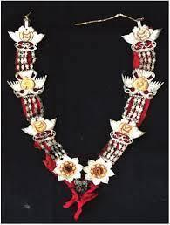

Image 1.Sultan Bima necklace decoration  Source: Ministry of Education and Culture Repository | Figure 2. Surya Majapahit Trowulan Museum collection (left) and National Museum Collection (right)  Source: National Archaeological Center Documents
The resemblance to the Majapahit Surya Symbol by symbolizing the eight directions of the compass after the Bima kingdom adopted Islamic law. The philosophy was changed into the philosophy of the ideal leader contained in the nggusu waru (octagonal) motif. Based on the Customary Law of the Land of Bima “Hukum Adat Tanah Bima” (HATB) at the time the Bima Sultanate was established (1640-1950 AD), a regulation was made prohibiting the application of human and animal motifs as a result of the concern that the Bima people would return to the belief in worshiping animals and spirits, resulting in the making of motifs on cloth. Bima weaving only applies floral and geometric shapes (Ismail & Malingi, 2010, p. 20). The images of these symbols, if any, have been stylized in such a way that the naturalist realist form is disguised, such as the kapi keu (crab claw) motif. These motifs are maintained as a reflection of the identity of the Bima people. Meanwhile, according to A. Malingi, the Bima woven cloth motifs consist of 10 motifs, namely:
(1) The samobo flower motif or a flower flower symbolizes humans as social beings to become useful humans in carrying out social life, so that wherever they exist they will always have a positive impact and always pay attention to noble character as the scent of a flower. (2) The satako flower motif or sprig is a motif as a symbol of harmonious family life like a flower that always grows together in every season. (3) The philosophical value contained in the aruna or pineapple flower motif gives a symbolic meaning in the form of 99 scales that symbolize Asma Ul-Husna (the names of Allah SWT), so that humans within their limitations must understand the 99 attributes of Allah SWT to be used as guidelines and examples. in life in this world and the hereafter. (4) The motif of kakando or bamboo shoots means patience and tenacity in facing every trial and challenge, just like bamboo shoots that are able to grow in the middle of a thick mother clump. (5) The stripe motif reflects the firm attitude of the Bima people in carrying out their duties, as a representation of the attitude commonly held by the maritime community. (6) The motif of nggusu tolu or triangle, the shape of the acute angle contained in the motif means that the law and the highest power in human life is in the hands of God.
Then (7) the nggusu upa (square) motif is a shape that describes the four directions of the compass which symbolizes the attitude of life of the Bima people who are open and social with immigrants from various directions. (8) The pado waji motif (parallelogram) is a symbol of the first level parallelogram symbolizing the supreme power of God. The second level parallelogram symbol symbolizes the power of the leader. The third level parallelogram symbol represents the lower level class. (9) The nggusu waru (octagonal) motif is related to the philosophical meaning in choosing leadership, namely: Macia ima roma taqwa (who has strong faith and piety to Allah SWT); Ma ntau ro ma ntau bade (who is knowledgeable, experienced, and broad-minded); Ma mbani ro ma paja sara (having patience and tolerance); Ma ndinga nggahi labo rawi (everything that is promised must be carried out); Ma taho hidi ro tohona (who is strong in body and mind); Londo ro mai dou ma taho (coming from a good lineage); Ma taho mori ra wokona (life in physical and spiritual prosperity) (Interview, April 2021). Meanwhile, (10) the kapi keu (crab claw) motif symbolizes a meaning adapted from crab, namely as the attitude of a beautiful and feminine girl with graceful movements like the slow motion of a crab. The main color of the fabric is usually dark blue, which symbolizes peace, with friendly strands, while yellow represents prosperity from gold threads and red represents courage (Mardyah, 2014; Rosmini, 2018).
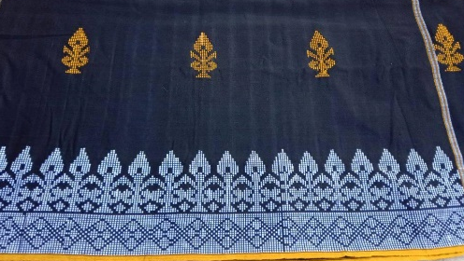
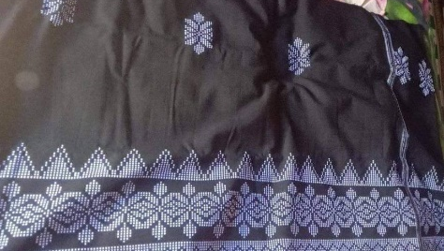

Figure 3. Samobo flower motif (a bunch flower)  Source:Author's Document | Figure 4. Satako flower motif (a sprig motif)  Source: Author's Document

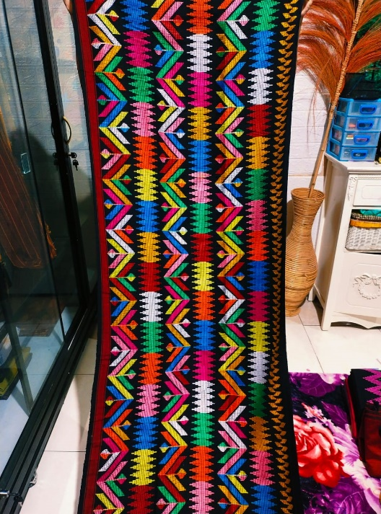
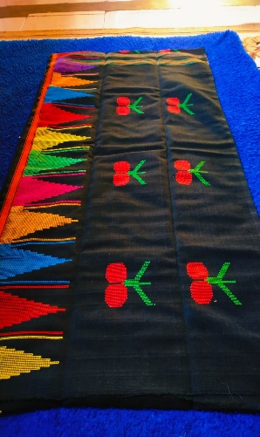

Figure 5. Aruna flower motif (pineapple)  Source: Author's Document | Figure 6. Kakando motif (bamboo shoots)  Source: Author's Document
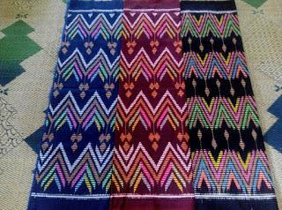
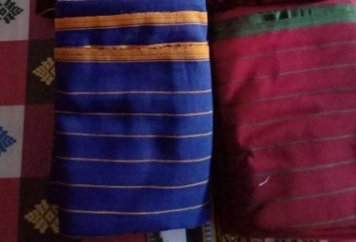

Figure 7. Line motif  Source: Author's Document | Figure 8. Nggusu tolu motif (triangle)  Source: Author's Document
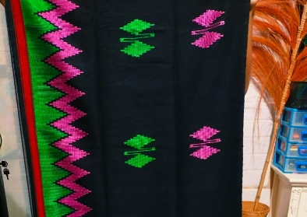
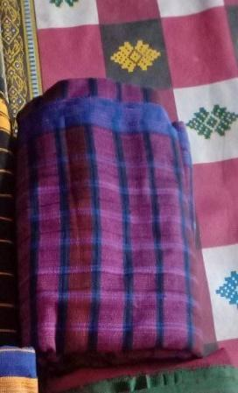

Figure 9. Nggusu upa motif (square)  Source: Author's documentation | Figure 10. Pado waji motif (parallelogram)  Source: Author's Document
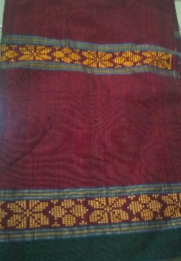
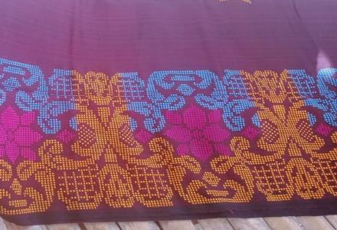

Figure 11. Nggusu waru motif (octagonal)  Source: Author's Document | Figure 12. Kapi keu motif (crab claw)  Source: Author's Documentation

In the Bima woven motif there are no sources explaining the caste differences of the wearer, although functionally the Bima woven fabric has similarities with the gotya woven fabric in Bali which has personal, social and physical function values ​​(Prayatna et al., 2021), but has a symbolic value. Bima's woven cloth motif is not like Javanese batik motifs. At the time of the 8th Sultan Hamengkubuwono, the symbolic meaning of classical batik motifs was used as a guide and order of life derived from the aesthetics, work ethic, and way of life of the Javanese bourgeoisie. Classical batik motifs represent a function and meaning in the palace community system in the past through parts that include names, types, colors, patterns and patterns of classical batik cloth, even batik at that time as a symbol of the legitimacy of power, and differentiating social status in society. Java, so it is cult by ordinary people as a splendor and social control (Roykhan, 2019). Although Van Braam Moris once mentioned the differences in clothing between ordinary people and the bourgeoisie in Bima, he only revealed that the way of weaving the Bima people was still very simple and rough and only worn by ordinary people, but he did not explain the differences in detail in the motifs. which is the basis of this difference. Even the informant's sources cannot provide certainty on this difference, because the application of motifs to Bima's woven cloth is not venerated to anyone, even though in court circles the symbols or motifs applied use a lot of satako flower motifs (a sprig) but the use of these motifs also used by ordinary people. The difference is only in the quality of the cloth used by the priyayi group with the common people, whether Bima is still in the status of a kingdom or after the entry of Islam and formed a sultanate. Although in the social life of the Bima community there are three prominent classifications, namely at the first level occupied by the Sultan and officials from the nobility level known as Ruma and Rato, the second level is followed by village heads, religious leaders and independent residents, and the last is a group of people who are pawned. These people were originally free people but as a result of their crimes or violations of the law, they were subject to fines, because they were unable to pay the fines they were pawned and worked as slaves (Zuhdi & Wulandari, 1997).
In the 21st century, the development of Bima's weaving motifs has varied, ranging from patterns, types, and colors, to the forms of decorative patterns. The impact of Bima's socio-political changes brought changes to the Bima people's philosophy of life. Customary law based on Islamic law is no longer a legal guide in social life so that the motifs of animals and humans in the plurality of weaver's democratic life can now be seen in the villages of Kale'o and Ntobo, the city of Bima. The development of this ornamental variety is much influenced by external culture and the interaction of the Bima community with the culture of decorative patterns obtained from commercialized motif books, the lack of knowledge of the craftsmen about the types of philosophical values contained in them, with outside culture through access to information that is available. quickly so that it affects changes in the pictures of woven fabric motifs.
CONCLUSION
Sumbawa Island is like a suburb on the map of Indonesia, this island is known for its multicultural variety of cultures and began to be widely known when entering international trade routes. Before the Dutch, Chinese, Arab, Bugis, Malay and European (Portuguese) traders had already started anchoring on the island of Sumbawa, precisely at Bima Harbor, so that Bima had more direct contact with these explorers. The main commodities in Bima include: cloth, sapan wood, cotton, wax, horses and honey. Bima's woven fabrics are especially admired by the people of Banda and Maluku. The motifs of Bima woven cloth, at first only recognized geometric shapes or primitive images, acculturation of Javanese culture around the XI-XVI centuries made the Bima community recognize the motifs of living beings (realists and naturalists) so that in the application of animal motifs and plants are adapted to freely woven fabric motifs. After the early seventeenth century Bima officially embraced Islam, Bima became a Sultanate system and implemented laws based on customary law and Islamic Shari'a, by stipulating geometric motifs, and stylized plants to prevent the Bima people from returning to the worship of ancestral spirits. through images of living things (fetishism). The results of this study indicate that there is very little historical evidence left in Bima and it is mostly obtained from old literature. For this reason, there needs to be more in-depth research to examine historical facts through archaeological remains and a hermeneutical approach that methodologically allows us to interpret, offer, and understand the content of all existing sources. This study provides an understanding to the Bima community regarding the philosophical values ​​contained in the Bima weaving motif, so that it can show the typical red thread or differences with other regional weaving motifs.
ACKNOWLEDGEMENTS
I would like to thank Lembaga Pengelolah Dana Pendidikan (LPDP) which has supported the funding during this research, Prof. Dr. Helius Sjamsuddin, MA as a professor of history from Universitas Pendidikan Indonesia willing to provide valuable knowledge and information related to history in Bima so that it can be used in completing information data, also conveyed to Mr. Alan Malingi (Ruslan Muhammad) as the head of the Asi Bima museum who has taken the time to provide his knowledge as informants, weaver in Simpasai, Kale'o and Rabadompu villages, who have helped a lot in finding historical sources as well as resource persons in this research.
REFERENCES
Bahauddin, A., & Aldrin, A. (2003). The songket motifs: between reality and belief. Tourism and histories: representations and experiences, University of Lancashire, Preston, UK, 1-13.
Chambert-Loir, H. (2004). Kerajaan Bima dalam sastra dan sejarah (2nd ed.). Kepustakaan Populer Gramedia.
Chambert-Loir, H., & Maryam, S. (2012). Bo’ Sangaji Kai Catatan Kerajaan Bima (2nd Ed). Yayasan Pustaka Obor Indonesia.
Dedy Prayatna, I. W., Santosa, H., & Ratna Cora, T. I. (2021). Perkembangan Fungsi dan Makna Kain Tenun Gotya dalam Industri Fashion. Mudra Jurnal Seni Budaya, 36(1), 106–114. https://doi.org/10.31091/mudra.v36i1.1101
Hitchcock, M. (1987). Michael Hitchcock the Bimanese Kris : Bijdragen, 143(1987), 125–140.
Ismail, H. M., & Malingi, A. (2010). Ragam Motif Tenun Bima Dompu. Mahani Persada Mataram.
Mardyah, S. (2014). Kerajinan Tenun Songket Di Perusahaan Ud Bima Bersinar Penaraga Kota Bima Nusa Tenggara Barat. In Cell (Vol. 151, Issue 4). http://dx.doi.org/10.1016/j.biochi.2015.03.025%0Ahttp://dx.doi.org/10.1038/nature10402%0Ahttp://dx.doi.org/10.1038/nature21059%0Ahttp://journal.stainkudus.ac.id/index.php/equilibrium/article/view/1268/1127%0Ahttp://dx.doi.org/10.1038/nrmicro2577%0Ahttp://
Mubin, I. (2018). Makna Simbol Atau Motif Kain Tenun Khas Masyarakat Daerah Bima Di Kelurahan Rabadompu Kota Bima Provinsi Nusa Tenggara Barat. Historis | FKIP UMMat, 1(1), 21. https://doi.org/10.31764/historis.v1i1.205
N, P. S., & Dewi, D. A. (2021). Produk Lokal Yang Mendunia Sebagai Bentuk Implementasi Pancasila. Jurnal Pendidikan Tambusai, 5(1), 937-943.
Noah Harari, Y. (2020). Homo Deus Masa Depan Umat Manusia (N. Wiyati (Edisi Terjemahan)). PT Pustaka Alvabet.
Parimartha, I. G. (2016). Perdagangan dan Politik di Nusa Tenggara 1815-1915. Penerbit Ombak.
Pires, T. (2018). Suma Oriental: Perjalanan dari Laut Merah ke Cina & Buku Fransisco Rodrigues (IV). Penerbit Ombak.
Prasetyo, O., & Kumalasari, D. (2021). Nilai-Nilai Tradisi Peusijuek Sebagai Pembelajaran Sejarah Berbasis Kearifan Lokal. Mudra Jurnal Seni Budaya, 36(September), 359–365. https://jurnal.isi-dps.ac.id/index.php/mudra/article/view/1387/719
Riana, I. K. (2009). Kakawin Desa Warnnana uthawi Nagara Krtagma ( Masa Keemasan Majapahit) (N. P. E. W. Citrawati & M. Suwacana (eds.); 1st ed.). PT Kompas Media Nusantara.
Rosmini, R. (2018). Bentuk dan Makna Simbolis Motif Sarung Tenun Songket Khas Suku Bima Nusa Tenggara Barat [Diploma Thesis, Universitas Negeri Makassar]. Eprints UNM. http://eprints.unm.ac.id/id/eprint/17154
Roykhan, R. (2019). Batik klasik sebagai simbol legitimasi kekuasaan Sultan Hamengkubuwono VIII tahun 1927-1939 dan relevansinya dalam pengembangan materi sejarah sosial [Undergraduate Thesis, Universitas Sebelas Maret]. Digilib UNS Repository. https://digilib.uns.ac.id/dokumen/detail/71650/Batik-klasik-sebagai-simbol-legitimasi-kekuasaan-Sultan-Hamengkubuwono-VIII-tahun-1927-1939-dan-relevansinya-dalam-pengembangan-materi-sejarah-sosial
Shanie, A., & Sumaryanto, T. (2017). Busana Aesan Gede dan Ragam Hiasnya sebagai Ekspresi Nilai-Nilai Budaya Masyarakat Palembang. Catharsis, 6(1), 49–56. https://doi.org/10.15294/catharsis.v6i1.17031
Sila, I. N. (2013). Kajian Estetika Ragam Hias Tenun Songket Jinengdalem, Buleleng. Jurnal Ilmu Sosial Dan Humaniora. https://doi.org/10.23887/jish-undiksha.v2i1.1311
Purwanti, R., & Siregar, S. M. (2016). Sejarah Songket Berdasarkan Data Arkeologi. Siddhayatra, 21(2), 97-106. Retrieved from https://core.ac.uk/download/pdf/227153334.pdf#page=40
Sjamsuddin, H. (2013). Memori Pulau Sumbawa Tentang Sejarah, Interaksi Budaya & Perubahan Sosial-Politik di Pulau Sumbawa. Penerbit Ombak.
Suartaya, K. (2011). Kumandang Sumpah Palapa Di Tanah Puputan. E-Journal ISI Denpasar. http://jurnal.isi-dps.ac.id/index.php/artikel/article/view/487
Susetyo, S. (2014). Pengaruh Peradaban Majapahit di Kabupaten Bima dan Dompu. Forum Arkeologi, 27, 121–134.
Tabrani, P. (2012). Bahasa Rupa (3rd ed.). Kelir.
Takdir, M., & Hosnan, M. (2021). Revitalisasi Kesenian Batik sebagai Destinasi Wisata Berbasis Budaya dan Agama: Peran Generasi Muda dalam Mempromosikan Kesenian Batik di Pamekasan Madura. Mudra Jurnal Seni Budaya, 36(3), 366-374. https://doi.org/10.31091/mudra.v36i3.1284
Taufiqurrahman. (2012). Sejarah Pelabuhan Bima. Penerbit Ombak.
Usop, T. B. (2021). Peran Kearifan Lokal Masyarakat Dayak dalam Mengembangkan Batik Benang Bintik di Kalimantan Tengah. Mudra Jurnal Seni Budaya, 36(3), 405-413. https://doi.org/10.31091/mudra.v36i3.1502
Van Braam Moris, D. F. (2014). Kerajaan Bima (1886) (N. O.Bana (Edisi Terjemahan)). Penerbit Lengger.
Wijaya, S. I., & Ardana, I. G. N. S. (2014). Kerajinan Tenun Songket Bima di Lingkungan Nggaro Kumbe Kelurahan Rabadompu Timur Kecamatan Raba Kota Bima Provinsi NTB. Jurnal Pendidikan Seni Rupa Undiksha, 4(1). http://dx.doi.org/10.23887/jjpsp.v4i1.4432
Zuhdi, S., & Wulandari, T. (1997). Kerajaan Tradisional di Indonesia: Bima. Retrieved from https://books.google.com/books?hl=en&lr=&id=stmECgAAQBAJ&oi=fnd&pg=PA19&dq=hujan+aliran+permukaan+penggunaan+lahan&ots=e2GtIK2RUM&sig=qGnXbFE0mgjEYhD3gxX5e7qrP6c
List of Resource Persons/Informants
Haninah, Haninah (73 years old), a hereditary weaver of Bima cloth, interviewes on 27 May 2021 at her home, Simpasai, Lambu, Bima, West Nusa Tenggara.
Malingi, Alan (48 years), Bima historian and writer (Head of ASI Bima Museum), interviewed on 24 April 2021 at the Bima ASI Museum, Rasa Nae, Bima City, West Nusa Tenggara.
Nurseha, Nurseha (51 years old), a hereditary weaver of Bima cloth, interviewed on 11 June 2021 at his home, Monta Baru, Lambu, Bima, West Nusa Tenggara.

